**LAPORAN UJIAN**

Mata Praktikum : Perancangan Analisis Algoritma

Kelas : 3IA24

Praktikum ke- : 5

Tanggal : 17 November 2023

Materi : Ujian

NPM : 50421704

Nama : Juan Samuel Christopher

Ketua Asisten : Sherina Permata

Nama Asisten :

Paraf Asisten :

Jumlah Lembar : 4



**LABORATORIUM TEKNIK INFORMATIKA**

**UNIVERSITAS GUNADARMA**

**2023**

**SOAL**

1. Carilah solusi optimal menggunakan **Knapsack** dari data berikut :



|  |  |  |
| --- | --- | --- |
| **i** | **wi** | **pi** |
| 1 | 2 | 20 |
| 2 | 5 | 30 |
| 3 | 6 | 34 |
| 4 | 3 | 12 |
| 5 | 1 | 3 |

Kapasitas Knapsack

**K = 14**

**Jawab :**

**Knapsack = 14**

|  |  |  |  |  |  |  |  |
| --- | --- | --- | --- | --- | --- | --- | --- |
| **PROPERTI OBJEK** | | | | **GREEDY BY** | | | **SOLUSI OPTIMAL** |
| **i** | **wi** | **pi** | **pi / wi** | **Profit** | **Weight** | **Density** |
| 1 | 2 | 20 | 10 | 1 | 1 | 1 | 1 |
| 2 | 5 | 30 | 6 | 1 | 1 | 1 | 1 |
| 3 | 6 | 34 | 5,6 | 0 | 0 | 1 | 1 |
| 4 | 3 | 12 | 4 | 1 | 1 | 0 | 0 |
| 5 | 1 | 3 | 3 | 1 | 1 | 1 | 1 |
| **TOTAL BOBOT** | | | | 14 | 11 | 14 | 14 |
| **TOTAL KEUNTUNGAN** | | | | 87 | 65 | 87 | 87 |

1. Urutkan data dibawah ini dengan menggunakan ***Bubble Sort***

|  |  |  |  |  |
| --- | --- | --- | --- | --- |
| 7 | 12 | 1 | 8 | 5 |

Jawab :

Iterasi ke – 1 = 7, 12, 1, 8 ,5 ::

7, 1, 12, 8, 5 ::

7, 1, 8, 12, 5 ::

7, 1, 8, 5, 12 :: ( terjadi 3 pertukaran)

Iterasi ke – 2 = 7, 1, 8, 5, 12 ::

1, 7, 8, 5, 12 :: ( terjadi 1 pertukaran)

Iterasi ke – 3 = 1, 7, 8, 5, 12 ::

1, 7, 5, 8, 12 :: ( terjadi 1 pertukaran)

Iterasi ke – 4 = 1, 7, 5, 8, 12 ::

1, 5, 7, 8, 12 :: ( terjadi 1 pertukaran)

**Hasil Bubble Sort : 1, 5, 7, 8, 12**

1. Tentukan rute terpendeknya beserta bobotnya!

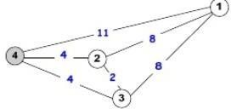

**Jawab :**

|  |  |  |
| --- | --- | --- |
| **No** | **Rute Perjalanan ( tour )** | **Bobot** |
| **1.** | 4 🡪 1 🡪 3 🡪 2 🡪 4 | 11 + 8 + 2 + 4 = 25 |
| **2.** | 4 🡪 1 🡪 2 🡪 3 🡪 4 | 11 + 8 + 2 + 4 = 25 |
| **3.** | 4 🡪 2 🡪 1 🡪 3 🡪 4 | 4 + 8 + 8 + 4 = 24 |
| **4.** | 4 🡪 2 🡪 3 🡪 1 🡪 4 | 4 + 2 + 8 + 11 = 25 |
| **5.** | 4 🡪 3 🡪 2 🡪 1 🡪 4 | 4 + 2 + 8 + 11 = 25 |
| **6.** | 4 🡪 3 🡪 1 🡪 2 🡪 4 | 4 + 8 + 8 + 4 = 24 |

Rute perjalanan terpendek adalah

**4 – 2 – 1 – 3 – 4**

**4 – 3 – 1 – 2 – 4**

Dengan bobot = **24**

1. Tentukan BFS nya

|  |
| --- |
| Start Node : H End Node :  BFS : T |

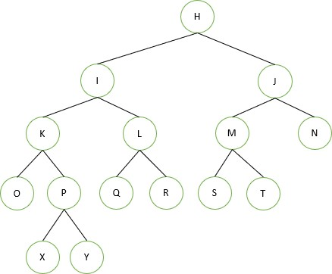

Queue

|  |  |  |  |  |  |  |  |  |  |  |
| --- | --- | --- | --- | --- | --- | --- | --- | --- | --- | --- |
| H |  |  |  |  |  |  |  |  |  |  |
| I | J |  |  |  |  |  |  |  |  |  |
| J | K | L |  |  |  |  |  |  |  |  |
| K | L | M | N |  |  |  |  |  |  |  |
| L | M | N | O | P |  |  |  |  |  |  |
| M | N | O | P | Q | R |  |  |  |  |  |
| N | O | P | Q | R | S | T |  |  |  |  |
| O | P | Q | R | S | T |  |  |  |  |  |
| P | Q | R | S | T |  |  |  |  |  |  |
| Q | R | S | T |  |  |  |  |  |  |  |
| R | S | T |  |  |  |  |  |  |  |  |
| S | T |  |  |  |  |  |  |  |  |  |
| T |  |  |  |  |  |  |  |  |  |  |

Visit Order

|  |  |  |  |  |  |  |  |  |  |  |  |  |
| --- | --- | --- | --- | --- | --- | --- | --- | --- | --- | --- | --- | --- |
| H | I | J | K | L | M | N | O | P | Q | R | S | T |